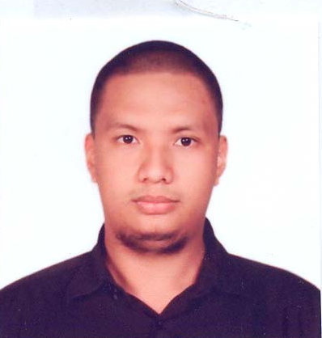
Mark Anthony A. Codina
# Block 10 Lot 18 Haniyyah Homes, Babag 1, Lapu Lapu City
Contact Information: +63947 767 4848
Email add: sparkmcfly@gmail.com
Highly accomplished customer service professional with progressive customer-client management experience encompassing competitive research, calls forecasting, profit and loss management, gross margin management. Performance-driven hiring manager experience in design, development and implementation of year on year ramp in a multi-million dollar international environments supporting up to 800 agents. Outstanding team manager consistently delivering key performance index metrics on or before time and thriving in a challenging, rapid learning environments. Resolving product and services problems by providing in a care throughout approach--end to end resolution and adequate feedback for loop monitoring .
PROFESSIONAL CV
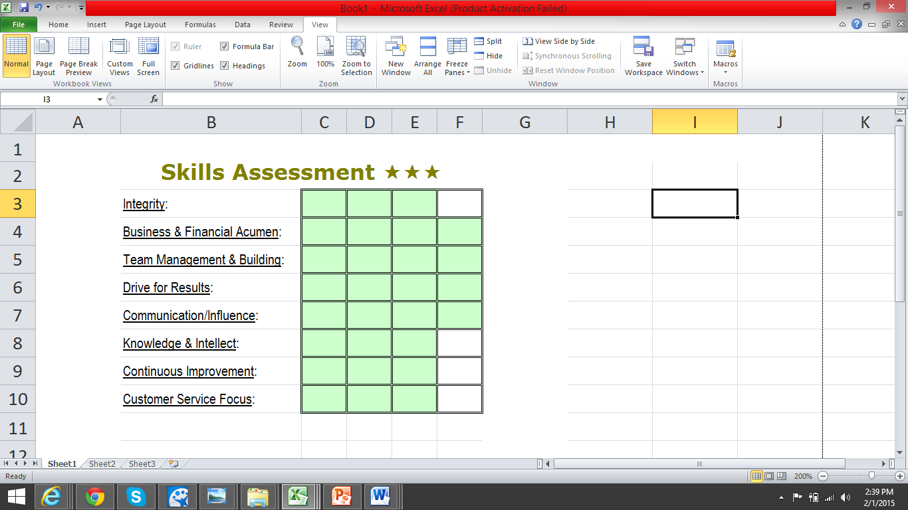
QUALIFICATIONS 

Bachelor of Science in Information Technology
University of Cebu / Cebu City / Philippines / 2006

Team Manager
- Handled a team for different US based clients such as Internet Service Provider/ Content Provider; Mobile phone provider & wireless communication services; financial software company for small business owners.
Special Tasks/Project Manager tasks
- Lead the Operations Validation hiring team, comprising of agents, subject matter experts & team managers.
- Lead the Rewards and Recognitions Team for the program of up to 800 agents and leaders.
- Lead the Work Force Management team, assuring schedule adherence, calls forecasting, plot off the phone activities, vacation plotting & service level.

Abilities 
- Well versed in MS Office app: Word, Excel, PowerPoint, Publisher, Access, Visio
- Familiar with different Customer Relationship Management software such as Siebel, Oracle & Salesforce apps
- Excellent communication skills and sales experience

Work Experience 
- January 2007 to present, Team Manager/ handles special tasks
- April 2004 to January 2007, Agent: Customer Service/ Tech Support
- March 2001 to April 2004, part time encoder/ office assistant

░░░░░░░░░░░░░░░░░░░░░░░░░░░░░░░░░░░░░░░░░░░░░░░░░░░░░░░
Details

Aside from managing an operations team, here are the program level tasks given to me:
- Since July 2012 (every Q3 & Q4 of the year): Lead the Operations Validation Hiring team: filters new applicants for specific line of businesses during ramp up months, focusing on client required categories. Was able to interview and filter up to 2000 applicants per yearly ramp.
- Since Dec 2012 (every Q1 & Q2 of the year): Lead the Rewards and Recognitions Team by providing enticing prizes, activities, party, and events. Balance budget between employee value fun activities and client value performance-based rewards. Was able to budget up to 6 digit funds on a monthly basis.
- 2010 to 2012: Handles scheduling of employees’ vacation leaves by analyzing previous week’s attendance, month to date attrition, call volume and tight intervals.
- 2008: Plot agents’ workstation based on site capacity meeting, headcount
- 2007: Plot agents’ off the phone activities, such as coaching, training, breaks, lunch and days off, based on previous data.
- Skill in verbal and written communication to analyze, interpret and address customer needs.
- Knowledge of contact services industry and best practices.
- Knowledge of PC applications (MS Office, Visio, Visual Basic, Access).
- Ability to work with minimal guidance or supervision in a time critical environment.
- Ability to be flexible and quickly adapt to changing business needs and processes.
- Ability to motivate and mentor team, presenting new opportunities and challenges for additional development.
- Skill in providing outstanding customer service through support of escalated customer issues.
- Ability to defuse situations, get to the issue and solve the problem.
- Skill in time management and multitasking.
- Skill in providing constructive feedback to others.
- Proven success in motivation and leadership.
- Demonstrated ability to coach and develop others to achieve desired results.
- Ability to make quick, accurate and appropriate decisions.
- Skill in providing an exceptional customer experience

eTelecare Global Solutions, Inc., bought by Stream Global Services, now Convergys Philippines Inc.
April 19, 2004- present
Team Manager
January 2007 to December 2007, handled a team for a US based Internet Service Provider/Content Provider
January 2008 to November 2008, handled a team for a US based mobile phone provider/wireless and wire line communications services.
December 2008 to present, handles a team for a US based financial software company for small businesses.

Responsible for the daily one-on-one supervision and management of all Support Professionals on assigned team, typically a minimum of 20 direct reports. Ensures service delivered to our customers meets contractual Key Performance Indicator ('KPIs') obligations of clients through the management of operational activity of the team. Implements systems and processes to achieve client-specified metrics while providing development opportunities to Support Professionals.

Customer Service Representative
November 2006 to January 2007
Explain and resolve member’s inquiry about their billing through inbound call and process the retention and cancellation of their account.
Process and review credit eligibility of the members.
Process customer’s account registration/creation over the phone.
Attempt to retain customer’s account by addressing their frustration thru listening to their complaints, feedbacks/suggestions, providing them other options they can choose from to retain their account active & if customer still refuses, provide them full disclosure of the cancellation facts & process details.
Available for work 24/7 (if needed) for the smooth operation of the program.

Technical Support Representative 2
April 19, 2004 to November 2006
Assists customers about their networking device/s, (LAN or IEEE 802.11 a/b/g/pre-n standard; wired or wireless routers, switch, network interface cards for both PC & laptop; PCI or USB connectivity for all Windows based & Macintosh-based Operating Systems.
Resolves customer’s concern with regard to their computer hardware issue over the phone for both desktop & laptop computer.

ATLAS Commission
November 2003- February 2004
Office Assistant
Setup Local Area Network for file and printer sharing.
Create web page using HTML code, macromedia flash for presentation purposes.
Handle PC repairs.

DPWH 3rd Engineering District Office, Toledo City
Computer Encoder (Job Order)
Mar 15 – June 15 of 2001, 2002 & 2003
Oct 15 – Nov 15 of 2001, 2002 & 2003
Summer/Semestral Break job.
Responsible for encoding & printing office paper works using Microsoft Applications (Word, Excel, and Publisher)

░░░░░░░░░░░░░░░░░░░░░░░░░░░░░░░░░░░░░░░░░░░░░░░░░░░░░░░
Educational Background
Bachelor of Science in Information Technology
University of Cebu / Cebu City / Philippines / 2006
Proficient in Java, Visual Basic, C++, Java script, VB script, PHP, macromedia, Adobe Photoshop
Training

- Cisco Networking Module 1 June – October 2003
- A+ Training for Desktop & laptop hardware T/S May 1 – June 15 2004
- LAN & wireless LAN product troubleshooting Sept 2004
- Customer Service Training April 2004
- Leadership Development Training January & March 2007
- Refresher: Leading the eTelecare Way training 2008
- Quality Assurance feedback process 2010
- Annual Refresher Course: Leadership Dev Training Since 2011
- Basic Life Support/ First Aid August 2014

Volunteer Service

Red Cross Youth June 2002 – March 2003 Member
Rotaract Club of Occidental Cebu July 2002 – March 2003 International Director
Radio/Rescue Emergency Assistance Volunteer Organization Active Member

Personal Information:

Marital Status: Married
Date of Birth: April 13, 1983
Nationality: Filipino
Religion: Roman Catholic

